Health Connect: Smart Mobile Application for Barangay Health Center of Barangay Poblacion Pres. Quirino, S.K

SHALIMAR P BAGUAN
MOHIDIN B. MABANG
ALLADIN G. ANTOLIN
NICKO K. NAVARRO
RASID S UNTUA

SUBMITTED TO THE FACULTY OF THE COLLEGE OF COMPUTER STUDIES VMC ASIAN COLLEGE FOUNDATION INC. IN PARTIAL FULFILLMENT OF THE REQUIREMENTS FOR THE DEGREE OF

BACHELOR OF SCIENCE IN INFORMATION TECHNOLOGY

JUNE 2025
Chapter l
INTRODUCTION

Background of the Study
Barangay health centers play a vital role in delivering primary healthcare services in local communities, particularly in areas like Barangay Poblacion Pres. Quirino where residents often rely on these facilities as their first, and sometimes only, point of contact for medical assistance. Despite this essential function, many of these centers continue to operate using fragmented and outdated systems. Patient records remain paper-based, appointment scheduling is handled manually, and medicine inventory tracking is prone to errors and delays. Health workers are burdened with managing personal records, immunization schedules, treatment histories, and patient communications without an integrated, reliable system. This leads to inefficiencies, long waiting times, missed appointments, and communication gaps that can compromise patient trust and the quality of healthcare services. Furthermore, the absence of real-time data hinders barangay decision-makers from effectively planning outreach activities, monitoring public health trends, and allocating resources where they are needed most.

Several studies support the importance of adopting digital health systems in local primary care facilities to improve operational efficiency and patient outcomes. According to Marquez et al. (2022), the integration of mobile-based health information systems in community healthcare centers significantly enhances record-keeping, appointment management, and medicine inventory monitoring, while also strengthening communication between health providers and patients. Similarly, research by Dela Cruz and Bautista (2021) highlights how mobile applications with features like immunization tracking, automated reminders, and real-time reporting can empower local health units to deliver more timely and organized healthcare services, especially in rural and underserved areas.
In Barangay Poblacion Pres. Quirino, S.K, the current manual processes present pressing problems that negatively affect healthcare delivery. The health center struggles with disorganized patient records, uncoordinated appointment schedules, and unreliable medicine inventory logs. Health workers face difficulties in keeping accurate immunization histories and often lack a dependable means to notify patients of upcoming appointments or follow-up visits. Moreover, patients experience long waits, missed reminders, and confusion about medical instructions due to poor communication channels. Without timely, accurate data, barangay officials are unable to make informed decisions about health resource management and public health initiatives, leaving the community vulnerable to preventable healthcare gaps.
To address these challenges, the proposed Health Connect: Smart Mobile Application for Barangay Health Center of Barangay Poblacion Pres. Quirino, S.K, aims to streamline and digitize core healthcare processes. The system will centralize patient record management, automate appointment scheduling with SMS and email notifications, monitor immunization schedules, and track medicine dispensation, including dosage and frequency. Additionally, it will feature real-time chat and feedback functionalities to improve patient-health worker communication, and a management dashboard to provide administrators with visual summaries of appointments, patient counts, and inventory status. Recognizing potential challenges related to functionality, accessibility, security, and system performance, the project will incorporate offline caching, user training, data encryption, and an intuitive interface to ensure the system enhances healthcare delivery without introducing new operational difficulties.
Objectives of the Study
General Objectives
This study generally aimed to develop and evaluate the “Health Connect: Smart Mobile Application for Barangay Health Center of Barangay Poblacion, Pres. Quirino, S.K.
Specific Objectives
This study specifically aims to:
- Develop a system that can manage barangay health worker’s account information.
- Allow barangay health workers to manage patient records, including personal details, medical history, and treatment information
- Enable patients to schedule appointments and receive automated SMS notifications for appointment reminders
- Develop a system for tracking and managing immunization schedules for both children and adults in the community.
- Provide a data dashboard with graphical presentation to track;
  - Number of appointments
  - Number of patients
  - Daily Appointment records
- Generate reports such as;
  - List of appointments
  - List of patients
  - Patient’s medical record
  - Appointment Slip
- Evaluate the system in form of;
  - Accuracy
  - Security
  - Functionality
  - Effectiveness
Significance of the Study
The project entitled: Health Connect: Smart Mobile Application for Barangay Health Center of Barangay Poblacion Pres. Quirino, S.K, holds significant value for various stakeholders in Barangay Poblacion, including barangay health center staff, barangay health workers, patients, and researchers. This system addresses critical gaps in healthcare delivery by transforming fragmented and manual processes into a cohesive, digital ecosystem. Through improved data management, streamlined workflows, and enhanced collaboration, the system ensures proactive care, better health accessibility, and data-driven decision-making. Ultimately, it empowers the barangay to tackle public health challenges efficiently, positioning Barangay Poblacion as a model for modern, equitable, and community-centered healthcare.
To the Barangay Health Center:
- Implementing Health Connect offers the health center a more streamlined, data-driven operation. Instead of relying on paper logs or scattered digital files, administrators gain a unified dashboard that clearly shows appointment trends, patient counts, and medicine inventory levels in real time. This reduces guesswork when allocating resources e.g., ordering supplies or scheduling staff and helps identify service bottlenecks early. At the same time, automated appointment slips and email reminders can lower no-show rates, optimizing slot utilization. However, it’s important to acknowledge upfront challenges: initial setup costs, reliable network/connectivity requirements, and ongoing maintenance. By assessing these honestly, the center can plan for contingencies (offline caching, periodic training refreshers) so the system truly boosts efficiency rather than becoming an extra burden.
To the Barangay Health Workers:
- For health workers, Health Connect can cut down on repetitive administrative tasks such as manually writing patient histories or tracking immunization dates on paper freeing more time for direct patient care. The digital patient record module ensures that medical histories, treatment notes, and immunization schedules are consistently organized and easily retrievable. Real-time chat and feedback feature mean workers can address patient questions between visits, potentially catching issues sooner. Yet adoption will require training and ongoing support, especially for those less comfortable with technology. A realistic rollout plan should include hands-on sessions, quick-reference guides, and perhaps a “buddy” system pairing tech-savvy staff with others, to ensure confidence and minimize frustration.
To the Patients:
- Patients stand to benefit from more convenient scheduling and clearer communication. With automated email reminders and printable slips, they are less likely to miss appointments, reducing anxiety and travel wasted. The real-time chat offers a safe channel for asking follow-up questions or reporting symptoms without waiting for the next visit, which can improve adherence to treatment plans and early detection of concerns. Tracking immunization schedules digitally also helps parents and adults keep up with recommended vaccines, reducing lapses. It’s crucial, however, to address digital access and literacy: some patients may lack smartphones, reliable internet, or comfort with email/chat. The study should explore fallback options (e.g., SMS reminders, phone calls, community kiosks) and include user education materials so the system is inclusive rather than exclusionary.
To the Researchers:
- Studying Health Connects implementation provides valuable insights into mobile health adoption in barangay settings. Researchers can evaluate usability, acceptance, and impact on key metrics (e.g., appointment adherence, record accuracy, inventory discrepancies) to contribute evidence on what works and what doesn’t in similar low-resource environments. Detailed evaluation of functionality, accessibility, security, and efficiency uncovers practical lessons: which features deliver the highest value, where connectivity or privacy concerns arise, and how training methods affect uptake. Findings can inform future iterations or scaling to other communities, and can be published as case studies or guidelines for digital health in grassroots contexts. Honest reporting of both successes and setbacks ensures others avoid repeating pitfalls.
To the Community and Policymakers:
- By demonstrating a working model in Barangay Poblacion Pres. Quirino, this study can influence policy decisions around digital health investments at the municipal or provincial level. Clear evidence of improved service delivery, patient satisfaction, and resource management can support proposals for funding similar systems elsewhere. Community leaders gain a concrete example of how technology can strengthen primary care, while also seeing the importance of addressing digital divides and data privacy policies. The study can spark dialogues on standards for barangay-level health data, interoperability with higher-level health information systems, and long-term sustainability plans (budgeting for maintenance, periodic upgrades, or integrating new modules).
To IT Developers and System Maintainers:
- The project highlights real-world requirements for building robust, user-friendly mobile health applications in resource-constrained settings. Developers learn about balancing feature richness with performance on low-end devices, designing intuitive interfaces for non-technical users, implementing offline-first strategies, and securing sensitive health data. Insights from the study such as common usability hurdles or integration pain points guide future development best practices. Maintaining the system over time also surfaces lessons on documentation, version control, and providing timely support. This significance encourages a culture of iterative improvement: collecting user feedback continuously and rolling out updates that address evolving needs without disrupting operations.

To Educators and Students:
- For those studying IT, public health, or related fields, Health Connect serves as a practical example of interdisciplinary collaboration: combining software development, healthcare workflows, user experience design, and evaluation research. Students can learn from the project lifecycle needs analysis, design, implementation, testing, deployment, and evaluation gaining hands-on understanding of challenges in community focused digital solutions. Educators might integrate case materials into curricula, prompting discussions on ethics (data privacy), accessibility, and sustainability in ICT for development. This real-world context enriches learning beyond textbook scenarios.
Scope and Limitation of the Study
This study focuses on the design, development, implementation, and evaluation of a mobile-based health platform called Health Connect, specifically created for the Barangay Health Center of Barangay Poblacion, Pres. Quirino, Sultan Kudarat. The system aims to improve healthcare service delivery through a centralized mobile application tailored to the needs of barangay health workers and local residents. The scope includes the creation of a module for managing health worker accounts, as well as a comprehensive patient record system that stores personal details, medical history, and treatment information. It allows patients to schedule appointments through the app and receive automated SMS notifications for reminders
Additionally, the application provides a user-friendly dashboard displaying graphical summaries of key data such as the number of appointments, patient count, and daily appointment records. Report generation features are included to produce lists of appointments and patients, patient medical records, medicine inventories, and appointment slips. The study also involves evaluating the system's performance in terms of accuracy, security, functionality, and effectiveness. Evaluation is conducted through a pilot deployment at the Barangay Health Center, with testing focused on the usability of the app in local contexts, including areas with low internet connectivity. The mobile application is developed for Android smartphones, considering the accessibility needs of users with limited technical knowledge and devices.
Despite its wide scope, the study is limited to the implementation and evaluation of the system within Barangay Poblacion, Pres. Quirino. Integration with municipal or national health information systems is not covered. Dashboard analytics are limited to basic counts and visualizations, without advanced data mining or predictive modeling. While the app offers offline caching for select features, full offline functionality with automatic data synchronization is beyond the scope. The platform is designed for Android only and does not include support for iOS, desktop, or tablet devices.

Definition of Term
The following terms were theoretically and operationally defined as used in this study:
Account Management - A system module that allows barangay health workers to securely create, edit, and maintain their personal and professional information within the mobile-based application. This ensures controlled access to patient records and system functionalities.
Appointment Scheduling - A system feature that enables patients to conveniently select their preferred consultation date and time via the mobile application. The system automatically sends SMS notifications to patients confirming and reminding them of their appointments.
Barangay Health Worker (BHW) - An accredited frontline healthcare provider in Barangay Poblacion Pres. Quirino responsible for delivering community health services, maintaining patient records, managing immunizations, dispensing medicines, and utilizing Health Connect for efficient service delivery.
Barangay Health Center - Primary healthcare facility providing consultations, maternal care, chronic disease management, and immunizations.
Data Dashboard - A visual, graphical feature of the system that presents real-time statistical summaries such as the number of appointments, total patients, and daily appointment records to assist barangay health workers in monitoring health center operations.
Evaluation Tools - A set of criteria and assessment tools within the system designed to measure the accuracy, security, functionality, and effectiveness of Health Connect based on user feedback and system performance
Immunization Schedule Management - A system module designed to record, track, and manage immunization schedules for both children and adults in the barangay. It ensures timely vaccination by providing alerts and status updates through the system.
Patient Medical Record Management - A core feature of the system that enables barangay health workers to input, store, and manage detailed patient information including personal details, medical history, diagnosis, immunization records, and treatment information.
Report Generation - The automated function of Health Connect to produce comprehensive reports such as lists of appointments, patient records, medicine inventories (by brand and supplier), appointment slips, and immunization records for documentation and decision-making.
Scheduling and Notification System - A component of the system that allows patients to book appointments and automatically delivers SMS notifications to their registered mobile numbers regarding their confirmed appointment date, time, and reminders.
System Administrator - The individual authorized to manage and oversee the technical operations of Health Connect, including user account management, data integrity checks, troubleshooting, and implementation of security protocols.
System Evaluation - The process of reviewing the Health Connect system’s operational performance based on parameters such as accuracy, security, functionality, and effectiveness, to identify areas for improvement and system updates.
Transaction History - A chronological digital record within Health Connect that captures all activities performed by health workers and patients, including registrations, appointments, immunization records, and consultation logs.

Chapter ll
REVIEW RELATED LITERATURE OF THE STUDY
This chapter discussed the relevant literature and studies of the study entitled “Health Connect: Smart Mobile Application Barangay Health Center of Barangay Poblacion, Pres. Quirino, S.K”

Related Studies
Patient Perspectives on Utilizing a Mobile Medical Clinic in Rural Philippine Communities
(Weiner et al., 2024). This qualitative study evaluated ABC-MMC, the first mobile primary healthcare clinic for chronic disease care in rural Pampanga barangays. Focus groups (N=57) found the mobile clinic was “well-received by rural Filipino communities,” improving access for hypertension/diabetes management. Relevance: Demonstrates high community acceptance of mobile clinic services in underserved barangays, providing lessons on engagement and continuity of care relevant to Health Connect’ s outreach design.

Implementing a mHealth-Based Patient and Nurse Educational Program to Reduce Wound Infection in Rural Philippines
(Henarejos et al., 2022). In this surgical mission study, rural Filipino patients received mHealth‐supported wound care education and follow-up via a secure mobile app. Between two mission years, surgical site infection (SSI) rates fell sharply from 28.8% to 9.7%. Relevance: Shows how a mobile health follow-up program can dramatically improve postoperative outcomes in low-resource rural settings, underlining Health Connect’ s potential impact on infection control through telemonitoring and patient education.

A Community-based Survey to Assess Risk for One Health Challenges in Rural Philippines using a Mobile Application
(Kim et al., 2022). This BMC One Health study conducted a large household survey (6,055 households in rural Laguna) using a tablet-based mobile app (the OH App). The authors note that “mHealth technology can provide an opportunity to systematically assess potential One Health problems in rural communities with limited internet connection”. Relevance: Demonstrates the feasibility of deploying mobile apps for wide-scale health data collection and monitoring in Philippine barangays, suggesting similar tools could support Health Connect’ s community health surveillance and needs assessments.

Stakeholder Perceptions towards a Mobile Application for Community-led Monitoring of Tuberculosis Services in Metro Manila, Philippines
(Tamayo et al., 2024). This qualitative study (Acta Medica Philippina) examined a pilot mobile app for TB service monitoring in an urban community setting. Both patients and TB healthcare providers found the app acceptable and useful (improving information access and reporting), while noting practical barriers (e.g. connectivity, cost, staffing). Relevance: Highlights user acceptance and implementation challenges of a Philippine community health app (for TB), providing insights into adoption issues (training, infrastructure) that Health Connect’ s must consider for scaling m Health solutions at the local level.

“Padayon”: a New Digital Health Model for Diabetes and Hypertension in Rural Philippines
(Paluyo et al., 2022). This report describes an offline-first mobile health platform used by community health workers (CHWs) in rural PH to manage NCDs. CHWs used the app to record patients’ blood pressure and glucose data; over time the program achieved notable health gains (community blood pressure fell by 29% and blood sugar by 8% compared to baseline). Relevance: Provides a successful example of an mHealth intervention designed for low-connectivity Philippine communities. The positive health outcomes and offline design are directly relevant to Health Connect goal of extending chronic disease care via technology in rural barangays.

Related Literature
Perspectives on telemedicine across urban, rural and remote areas in the Philippines during the COVID-19 pandemic
(Dans et al., 2024). In a mixed-methods survey, Filipino telemedicine users and non-users identified benefits (reduced COVID exposure, lower costs, convenience) as well as barriers (limited devices/infrastructure, patient/provider readiness). Both groups emphasized that substantial investment and training are needed for telehealth to bridge rural health gaps. Relevance: Indicates that for initiatives like Health Connect’ s, improving connectivity, technical support and training are crucial to foster telehealth adoption and equity in rural/remote PH areas.

Patient satisfaction with telemedicine in the Philippines during the COVID-19 pandemic: a mixed methods study
(Noceda et al., 2023). This study surveyed patients using Philippine telemedicine services. Most respondents were satisfied, finding telehealth “safe, efficient, and affordable”. However, they also reported challenges (costs, internet reliability, and concerns about clinical quality). The authors recommend strengthening infrastructure and provider training to sustain rural telehealth usage. Relevance: Confirms that Filipino patients appreciate telehealth’s convenience, but highlights the need for robust support and quality assurance in community settings lessons directly applicable to Health Connect’ s user engagement and service design.

Factors influencing the acceptance of telemedicine in the Philippines
(Ong et al., 2022). Using the UTAUT2 behavioral model with 533 Filipino respondents, this study identified key drivers of telemedicine adoption. It found that actual usage behavior was the strongest predictor of intention to use telemedicine, with factors like performance expectancy (perceived usefulness), effort expectancy, social influence, and resistance to use significantly affecting uptake. Relevance: Offers a theoretical understanding of what motivates Filipino users to adopt telehealth. Health Connect’ s can leverage these insights (e.g. emphasizing usefulness and ease-of-use, enlisting community influencers) to improve adoption of mobile health tools in barangays.

The use and potential impact of digital health tools at the community level: results from a multi-country survey of community health workers
(Blondino et al., 2024). In a global survey of 1,141 CHWs (308 from the Philippines), the authors found that CHWs overwhelmingly believe digital tools enhance their impact. Formal training strongly increased CHWs’ use of digital devices, whereas cost barriers (mobile/data expenses) significantly reduced usage. Relevance: Suggests that Philippine barangay health workers are open to using mobile health tools if given proper training, but cost/access is a major constraint. This informs Health Connect’ s that investing in CHW training and minimizing tech costs will be key to successful implementation.

Feasibility and acceptability of asynchronous video-observed therapy (VOT) among patients with drug-resistant tuberculosis in the Philippines
(Casalme et al., 2022). This pilot study equipped MDR-TB patients with a smartphone app to video-record medication intake, allowing remote monitoring. Of 308 patients approached, 36% chose VOT; among them 67% achieved >90% adherence and the treatment success rate were 88%. Nearly all health workers (90%) viewed VOT positively, citing convenience, privacy, and comfort as benefits. Relevance: Demonstrates that community-based mobile telehealth (for TB treatment) can be accepted by both patients and providers in PH. It provides a model for how Health Connect’ s could use video or mobile technologies to monitor treatment or health behaviors in rural barangay
Conceptual Framework
INPUT
OUTPUT
PROCESS
Determine
- Manual record-keeping and communication were the default process.
- Inventory tracking was done using hand written logs approval.
- Appointments were handled via face-to-face or informal messages.
- Feedback collection and patient monitoring lacked a structured system.
Assess
- Time-consuming and error-prone manual system.
- Difficult to trace medicine stock and immunization schedules.
- No real-time access to patient information for staff.
Identify
- High dependency on paper-based
- Accidental loss of distribution records occurred due to paper-based tracking.
Recommendation
- Digitization of health center operation via Health connect.

“(HEALTH CONNECT: SMART MOBILE APPLICATION FOR BARANGAY HEALTH CENTER OF BARANGAY POBLACION, PRES. QUIRINO, S.K)”

- Resident/Patient Information Details
- Barangay Health Worker Account Details
- Medical Records
- Appointment Schedule
- Medicine Inventory Data
- Immunization Records

FEEDBACK
Figure 1. Conceptual Framework of the Study
Figure 1 shows the conceptual framework of the study through input, process, and output presentation.

INPUT
The INPUT stage comprises the collection of critical information necessary for barangay health operations. This includes resident or patient personal data, barangay health worker account credentials, medical histories, consultation records, appointment schedules, and immunization records.

PROCESS
The PROCESS the researchers assessed the limitations of the current manual system, identifying inefficiencies such as delays in patient service, disorganized record-keeping, and the lack of real-time access to vital data. Through this analysis, the study determined that the manual handling of health records was time-consuming and error-prone. The system development process addressed these problems by designing an automated and centralized platform that offers digital appointment scheduling, SMS reminders, immunization scheduling, and health data dashboards for analytics.
OUTPUT
The OUTPUT is the development of Health Connect: Smart Mobile Application for Barangay Health Center of Barangay Poblacion, Pres. Quirino, S.K. This system improves healthcare service delivery by streamlining health data management, enhancing communication between patients and health workers, and automating routine tasks. The platform enables the barangay health center to provide more accurate, timely, and accessible health services, while also generating automated reports for better planning and decision-making. Ultimately, the system empowers both healthcare providers and patients, contributing to a more efficient and responsive community health system.

FEEDBACK
This FEEDBACK is used to assess the effectiveness of the system, identify areas for improvement, and implement updates or feature enhancements. The continuous feedback loop ensures that the system evolves based on user needs and remains relevant, responsive, and user-centered in addressing the community’s healthcare demands.

Chapter ll
METHODOLOGY
This chapter presented the Methodologies and Materials used in the study.

Project Development Description

Materials
The following materials were identified and acquired by the researchers to ensure that the development process would not be delayed.
Hardware Requirements
QTY. | COMPONENTS | SPECIFICATION
1 | PC | (8Gb RAM, Intel Core i7, 1 TB (HDD))
1 | PRINTER | Brother
 | Other Peripherals | Keyboard, mouse, mouse pad, flash drive
1 | WI-FI | PLDT

Table 1 showed the tabular representation in the hardware requirements that was used in developing the system, the researchers provided 1 laptop with the brand and specifications such as PC (8Gb RAM, Intel Core i7, 1 TB (HDD)), 1 printer, (Brother) and 1 Wireless Fidelity, (PLDT Wi-Fi).

Table 2. Software Requirements
Database Application | Xampp (phpMyAdmin, MySQL)
Web Scripting Languages | PHP, HTML, CSS, JavaScript
Front-end Framework/Web Framework | Bootstrap
Web Designing Tools | HTML, CSS, Ajax
Operating System | Windows 10 and 11
Office Application | WPS (Word, and Powerpoint)

Table 2 showed the tabular representation of the software requirements used in the system. The researchers used the following software applications and tools in the development of the system: Web Scripting Languages (PHP, HTML, CSS, JavaScript), Front-end Framework/Web Framework (BOOTSTRAP), Web Designing Tools (HTML, CSS, Ajax), Operating System (Windows 10 and 11), and Office Application WPS (Word and PowerPoint).

Table 3. Budgetary Requirements
Quantity | Description | Unit Price | Amount
Software
 | SMS API | 300.00 | 3300.00
 | Website Hosting | 3,000.00
Hardware
 | QR Code Scanner | 5,000.00 | 5,000.00
Materials
1 Ream | Bond Paper | 190.00 | 1,190.00
 | Prints | 1,000.00
Miscellaneous
 | Outline Defense English Critic Statistician Final Defense | 400.00  1,000.00  700.00  5,000.00 | 7,100.00
Sub Total |  |  | 44,290.00
 | Contingency (10%) |  | 4,429.00
Overall Total |  |  | 48,719.00

Table 3 showed the bills of supplies and materials used in the system as well as the miscellaneous bill for incidental expenses and supplies
Activities | Duration (AY 2023-2025)
Activities | Aug | Sept | Oct | Nov | Dec | Jan | Feb | Mar | Apr | May
Conceptualization For Title Proposal
Title Defense
Gathering Tools and Equipment
Outline Defense
Construction Of Project
Testing
Finalization Of Design Project
Gathering Data and Information
Final Defense
Finalization Of Manuscript

Project Duration
Table 4 show the timeline, task, duration, of the project, and expected completion date. It also displays the horizontal bar chart that shows the expected project’s planned schedule and task over the assigned timeframe. The horizontal axis represents the time or the months and the vertical axis shows the task involve the development system.

Methods Used in Developing the System
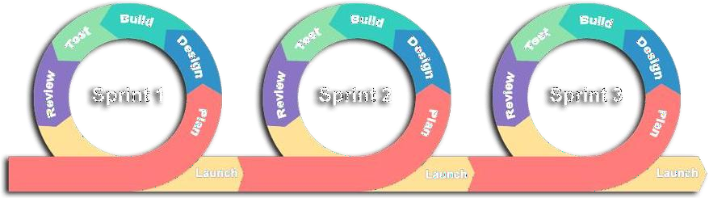
Agile Software Development Methodology was developed to ensure satisfaction of the requirements among existing computerized system. It is a methodology construction to make sure that the requirements planning, development and implementation, testing of the system follows logical approach and technical ways.

Figure 2. Agile Methodology Model
Sets of related activities are organized inside of Agile Model
- Plan
- Design
- Build
- Test
- Review
- Launch

Sprint 1
In this sprint, the team gathers detailed requirements by engaging barangay health workers and a small group of representative patients, clarifying workflows for account management, patient records, appointment flows, medicine logs, chat needs, immunization tracking, dashboards, and report formats. Simultaneously, the technical environment is provisioned: selecting frameworks (e.g., cross-platform mobile tech or responsive web), backend stack, database schema baseline, version control, CI/CD pipelines, and basic security policies (authentication approach, encryption standards). A lightweight prototype or wireframes for key screens (login, patient list, appointment booking) are sketched and reviewed with stakeholders. The sprint ends with a refined product backlog, user stories prioritized, and a minimal working development environment ready—ensuring the team can start building features with confidence about scope boundaries, accessibility considerations (low-end devices, minimal data use), and performance constraints. The researchers planned out the user registration form, application modules, and submission process through a responsive web-based system. During this phase, diagrams such as context diagrams, data flow diagrams (DFD), and entity relationship diagrams (ERD) were created to outline the process flow and data handling procedures. Development tools used included PHP for server-side scripting, Bootstrap for front-end design, HTML/CSS for structure and styling, and MySQL for database management. The feature was tested for functionality and data accuracy before being launched

Sprint 2
This sprint focuses on implementing user registration, login, profile management, and access control for health workers. The team builds secure authentication (e.g., email/password with hashing, optional two-factor if feasible) and role-based access scaffolding (even if roles are simple now, such as “health worker” vs. “admin”). Validation and basic UI/UX considerations (clear forms, error messages) are prioritized to ensure usability for non-tech-savvy staff. Offline handling is considered (e.g., caching credentials securely for intermittent connectivity). By sprint’s end, health workers should be able to create accounts, log in, update profiles, and log out reliably, forming the foundation for all subsequent modules. Basic automated tests for authentication flows and security checks (e.g., password strength enforcement) are added. The researchers planned out the user registration form, application modules, and submission process through a responsive web-based system. During this phase, diagrams such as context diagrams, data flow diagrams (DFD), and entity relationship diagrams (ERD) were created to outline the process flow and data handling procedures. Development tools used included PHP for server-side scripting, Bootstrap for front-end design, HTML/CSS for structure and styling, and MySQL for database management. The feature was tested for functionality and data accuracy before being launched

Sprint 3
This sprint develops CRUD for patient profiles: capturing personal details, medical history entries, treatment notes, and immunization records placeholders. Emphasis is on intuitive forms (grouping fields logically), search/filter basics, and data validation (e.g., date formats). The UI should work smoothly on low-end devices, with sensible defaults and offline draft saving if connectivity drops. The backend schema is extended for patient tables, ensuring data privacy (access control so only authorized users see records). Prototypes are tested with a small group of health workers to refine field labels and workflows. By the end, health workers can create, view, edit, and delete patient records; basic list views and search allow quickly finding a patient. This sprint also establishes audit logging (who accessed/edited records) to support security evaluation later. The researchers planned out the user registration form, application modules, and submission process through a responsive web-based system. During this phase, diagrams such as context diagrams, data flow diagrams (DFD), and entity relationship diagrams (ERD) were created to outline the process flow and data handling procedures. Development tools used included PHP for server-side scripting, Bootstrap for front-end design, HTML/CSS for structure and styling, and MySQL for database management. The feature was tested for functionality and data accuracy before being launched

Sprint 4
Building upon patient records, this sprint adds an immunization schedule module: defining vaccine schedules (e.g., recommended ages/dates for childhood vaccines, adult boosters) and linking them to patient profiles. The system calculates upcoming due dates and triggers reminder emails. Health workers can mark vaccinations as administered, updating records and inventory logs if vaccines are in scope. The UI shows upcoming immunizations per patient, and a list of patients due for vaccines in a given period. Offline considerations apply: allow recording administered vaccines offline with sync later. Usability testing ensures the flow matches existing immunization workflows. By sprint’s end, health workers can manage immunization schedules: schedule, remind, and log vaccine events for children and adults. The researchers planned out the user registration form, application modules, and submission process through a responsive web-based system. During this phase, diagrams such as context diagrams, data flow diagrams (DFD), and entity relationship diagrams (ERD) were created to outline the process flow and data handling procedures. Development tools used included PHP for server-side scripting, Bootstrap for front-end design, HTML/CSS for structure and styling, and MySQL for database management. The feature was tested for functionality and data accuracy before being launched.

Sprint 5
This sprint introduces a text-based messaging channel between patients and health workers. Given constraints, it may be implemented as near-real-time (e.g., long polling or lightweight WebSocket if connectivity allows) or asynchronous messaging stored in the system. UI should notify health workers of unread messages; patients can send questions or feedback via the mobile/web interface. Security/privacy is crucial: messages are linked to patient records, encrypted in transit, and accessible only by authorized health workers. The flow includes notification handling (e.g., push notification or an in-app alert) if feasible. During the sprint, test with a small group to fine-tune UX: ensure conversations are threaded or organized per patient, with clear timestamps. By sprint’s end, messaging is functional: patients can send queries and health workers can respond, with messages logged in the system for audit and follow-up. The researchers planned out the user registration form, application modules, and submission process through a responsive web-based system. During this phase, diagrams such as context diagrams, data flow diagrams (DFD), and entity relationship diagrams (ERD) were created to outline the process flow and data handling procedures. Development tools used included PHP for server-side scripting, Bootstrap for front-end design, HTML/CSS for structure and styling, and MySQL for database management. The feature was tested for functionality and data accuracy before being launched.

Sprint 7
The team builds a dashboard showing key metrics: appointment counts over time (e.g., weekly/monthly trends), total active patient counts, upcoming appointments. Reports for lists of appointments, patient registries are implemented with export options (PDF or CSV). Attention is paid to performance: queries are optimized to avoid slow loading on limited bandwidth. Accessibility checks ensure readability of charts (e.g., clear labels). Prototype dashboards are reviewed with health workers to ensure insights align with decision needs. By sprint close, the dashboard and reporting features are live, offering actionable visuals and exports. The researchers planned out the user registration form, application modules, and submission process through a responsive web-based system. During this phase, diagrams such as context diagrams, data flow diagrams (DFD), and entity relationship diagrams (ERD) were created to outline the process flow and data handling procedures. Development tools used included PHP for server-side scripting, Bootstrap for front-end design, HTML/CSS for structure and styling, and MySQL for database management. The feature was tested for functionality and data accuracy before being launched.

Sprint 7
This sprint is dedicated to comprehensive testing and evaluation. Functionality testing involves end-to-end scenarios for all modules, capturing bugs and usability issues. Accessibility evaluation includes basic usability tests with users of varying digital literacy, checking interface clarity, data usage, and offline behaviors; adjustments (e.g., simpler navigation, help prompts) are made. Security assessment covers reviewing authentication flows, encryption in transit/storage, and basic vulnerability scans or checklist reviews; fixes are applied (e.g., secure headers, input sanitization). Efficiency/performance tests measure load times under simulated low-connectivity conditions; optimize caching strategies or reduce payload sizes if needed. The team documents known limitations (e.g., features requiring intermittent connectivity) and proposes workarounds. By sprint end, a clean evaluation report is produced, with prioritized action items for fixes or future phases. The researchers planned out the user registration form, application modules, and submission process through a responsive web-based system. During this phase, diagrams such as context diagrams, data flow diagrams (DFD), and entity relationship diagrams (ERD) were created to outline the process flow and data handling procedures. Development tools used included PHP for server-side scripting, Bootstrap for front-end design, HTML/CSS for structure and styling, and MySQL for database management. The feature was tested for functionality and data accuracy before being launched.

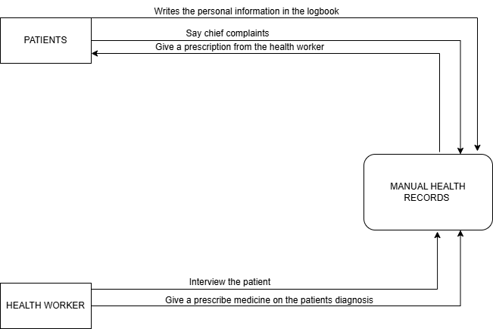
Context Diagram (Existing System)

Figure 3. The Context Diagram of the Existing System
Figure 3 showed the diagram of the existing system illustrates the high-level interactions between external entities and the central "Manual Health Records" process. This diagram depicts two primary external entities: "Patients" and "Health Workers." Patients interact with the system by providing their "chief complaints" and receiving a "prescription from the health worker." They also have their "personal information written in the logbook," which is then integrated into the "Manual Health Records." On the other hand, Health Workers "interview the patient" and "give a prescribed medicine on the patients diagnosis," with these activities directly influencing and being influenced by the "Manual Health Records." The diagram highlights the manual nature of the current system, where all information flows through and is managed within the "Manual Health Records" entity.

Data Flow Diagram (Existing System)
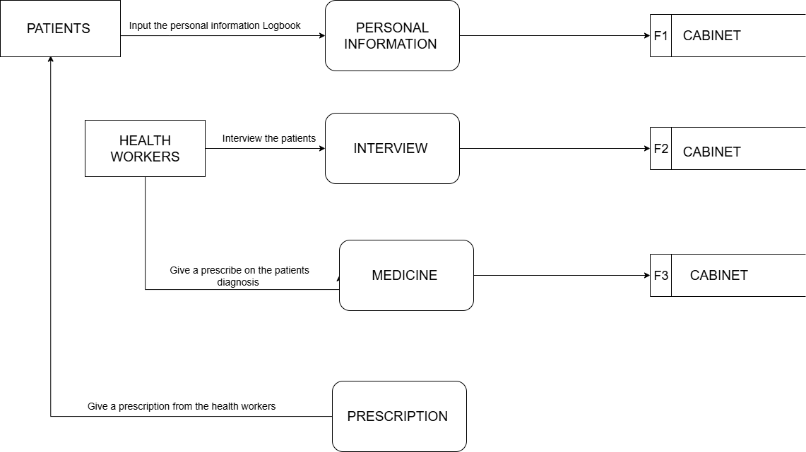
Figure 4. Data Flow Diagram (Existing System)
Figure 4 showed the manual operations and information flow of the existing system. The existing system for managing patient information is a largely manual and physical process, involving interactions between Patients and Health Worker. Patients initiate the process by providing their personal details, which are then recorded and stored in a physical "F1 Cabinet." Concurrently, Health Workers conduct interviews with patients, and the resulting interview information is documented and stored in a "F2 Cabinet." Following the interview, Health Workers prescribe medicine based on diagnoses, with the details of the prescribed medication being recorded and filed in a "F3 Cabinet." Finally, Health Workers issue prescriptions to patients, marking the culmination of the patient's interaction with the system. This setup indicates a traditional, paper-based approach to record-keeping, relying on physical storage for all critical patient data.

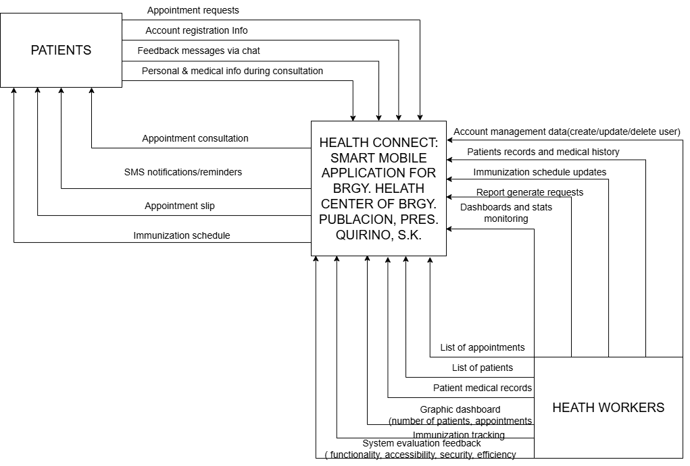
Context Diagram (Proposed System)

Figure 5. The Context Diagram of the Study
Figure 5 illustrates the core functions and interactions between the main users’ patients and health workers and the system. It emphasizes how the mobile application serves as a centralized platform for managing health worker accounts, handling patient records, and monitoring immunization schedules. Patients can register accounts, submit appointment requests, and receive SMS notifications and appointment slips. Health workers, on the other hand, can manage patient medical records, update immunization schedules, and monitor system statistics through a dashboard that visualizes patient and appointment data. The system also supports automated report generation, allowing health workers to generate lists of patients, and appointments. Additionally, the system is designed to be evaluated based on functionality, security, accessibility, and efficiency. This context diagram highlights the automated and integrated nature of the system, reducing manual processes and improving communication between patients and health professionals.

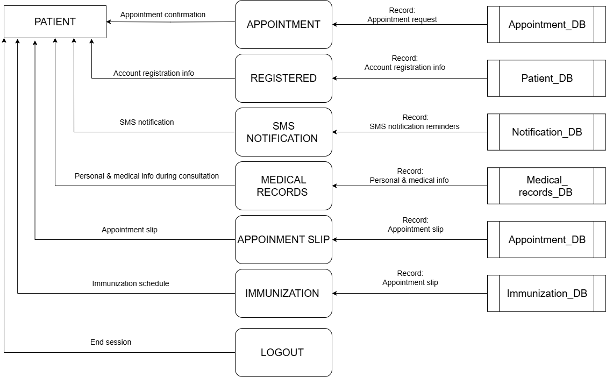
DATA FLOW DIAGRAM (Logical)
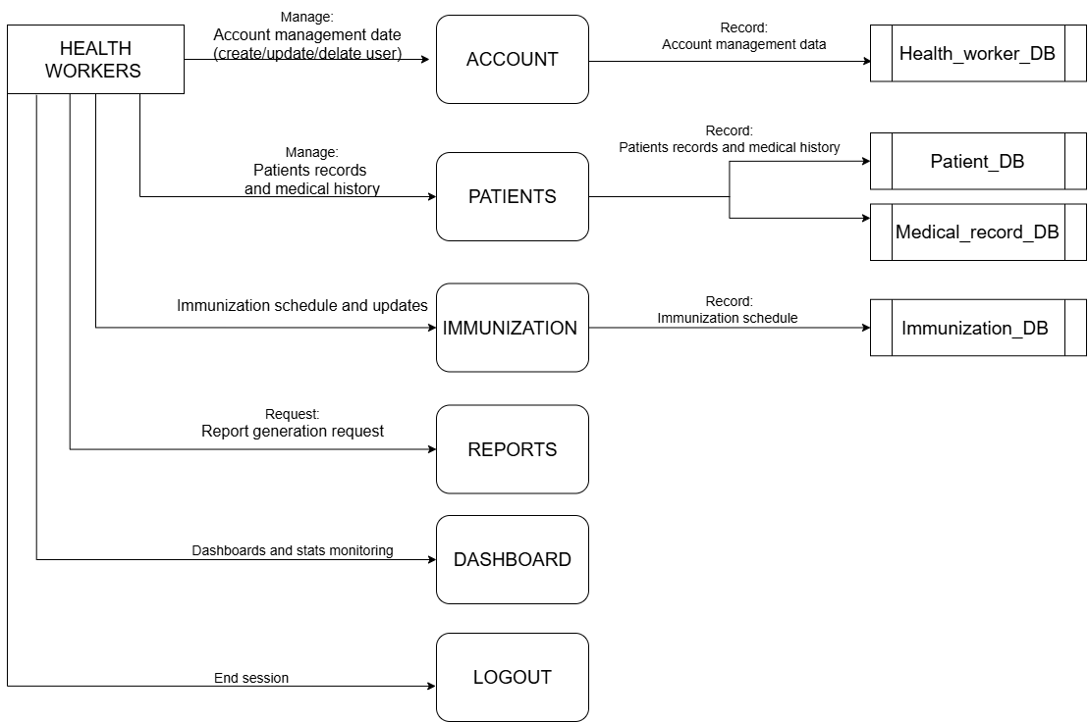
Figure 6. The Logical Data Flow Diagram of the System
Figure 6 shows the healthcare management system designed around two primary user roles: Patients and Health Workers. Patients initiate interactions by registering accounts storing their information in the Patient_DB and requesting appointments, which are logged in the Appointment_DB. During consultations, they provide personal and medical details that are recorded in the Medical_record_DB. Patients can also submit feedback and chat messages, and receive SMS notifications such as appointment confirmations managed through the Notification_DB. Additionally, they access immunization schedules from the Immunization_DB, view their medical records, and generate appointment slips for upcoming visits.
Health Workers, on the other hand, manage a broader range of system workflows. They oversee appointments, review and update patient profiles in the Patient_DB, and maintain detailed medical histories in the Medical_record_DB.
The system emphasizes smooth data synchronization across eight core databases: Patient_DB (registration), Medical_record_DB (health history), Appointment_DB (bookings), Immunization_DB (vaccine scheduling), Notification_DB (SMS alerts), and Health_worker_DB (staff credentials). Key processes include appointment coordination (linking patient requests to health worker schedules), medical data consolidation (updating records during consultations), and automated notifications (sending SMS confirmations). As a logical DFD, this model abstracts away technical implementation details such as infrastructure or security and focuses instead on the flow of data, user interactions, and storage mechanisms to represent a streamlined, patient-centric healthcare workflow.

DATA FLOW DIAGRAM (Physical)
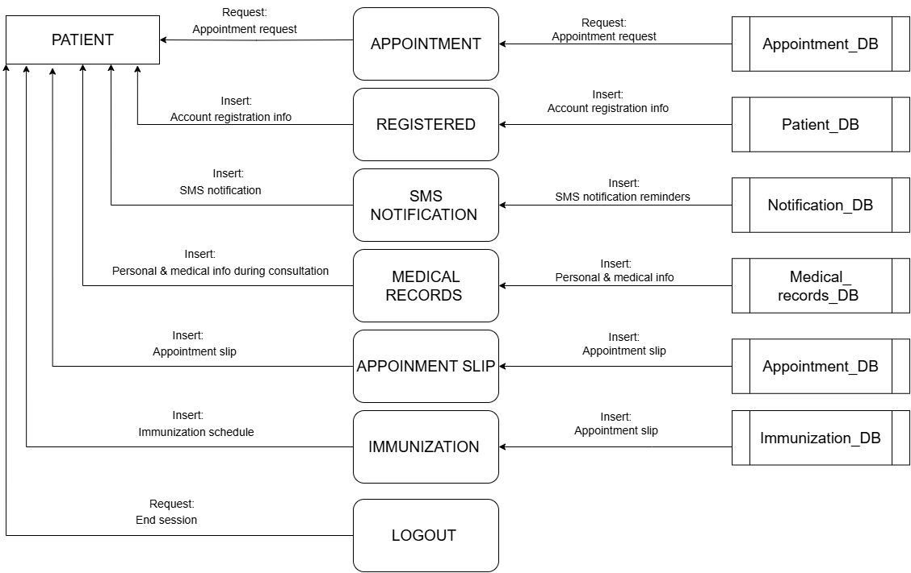
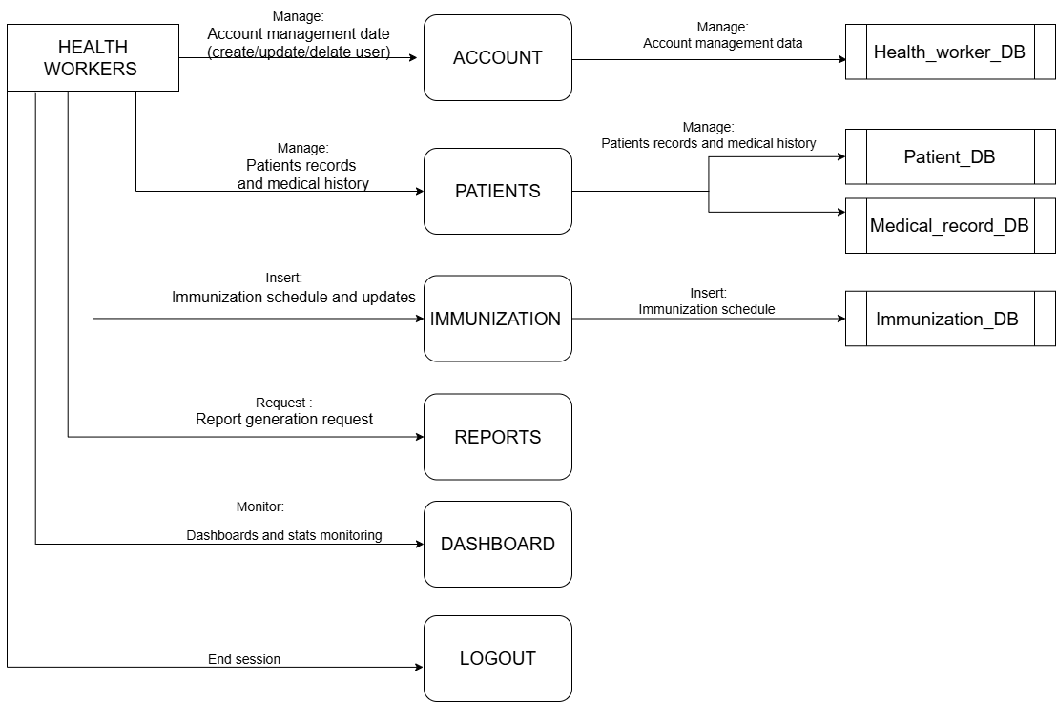

Continued…
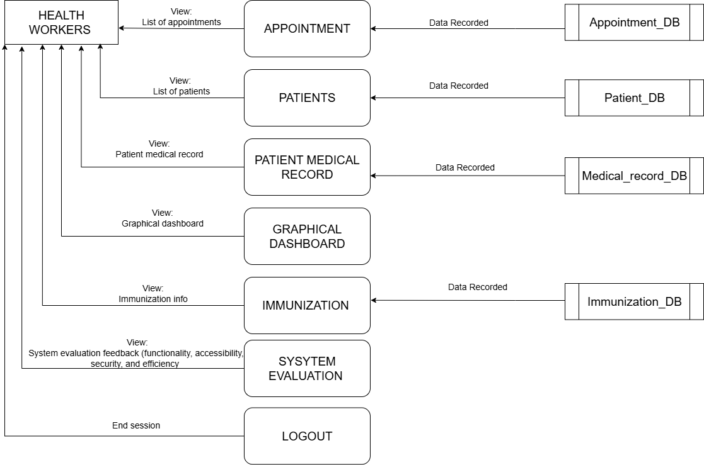
Figure 7. The Physical Data Flow Diagram of the System
Figure 7 presents an implementation-specific view of a healthcare management system, building upon the logical model by incorporating concrete components, technologies, and workflows. It restrains the dual-user structure of Patients and Health Workers, but adds physical elements such as SMS notifications, graphical dashboards, and explicit interactions with system databases.
For Patients, the workflow begins with appointment booking and registration through the Appointment module. During registration, personal details are stored in the Patient_DB, while confirmed bookings result in the creation of an Appointment Slip stored in the Appointment_DB and trigger automated SMS alerts via the Notification_DB. Patients can access their historical health data from the Medical_record_DB and review vaccination schedules stored in the Immunization_DB. Patient sessions conclude with a logout process.
Health Workers manage a range of operational tasks. They handle appointments via the Appointment_DB, access demographic data from the Patient_DB, and consult or update medical histories in the Medical_record_DB during consultations. Vaccine administration and monitoring are handled through the Immunization_DB. Analytical functions are supported through Graphical Dashboards, which visualize data trends such as appointment volumes and medicine inventory levels. A System Evaluation module helps monitor system performance. Reports are generated as needed, and sessions end with a logout.
Several key physical components enhance system functionality. The SMS Notification System, integrated with the Notification_DB, automates appointment alerts. Real-time Graphical Dashboards render analytics such as immunization coverage and resource utilization. All core data is stored in centralized databases, including Patient_DB (registration), Appointment_DB (bookings), Medical_record_DB (health records), Immunization_DB (vaccines), and Health_worker_DB (staff credentials).
The Implementation-Specific Workflow for patients typically follows the sequence: Registration → Appointment → SMS Alert → Consultation → Medical Record Access → Logout. For health workers, it proceeds as: Appointment Review → Patient Profile Check → Medical Record Update→ Dashboard Analytics → Logout.
This physical DFD distinguishes itself from the logical model by introducing physical artifacts like the SMS gateway (Notification_DB), appointment slip generation, and interactive dashboards.
Ultimately, the purpose of this physical DFD is to illustrate how the system operates in a practical environment. Patients benefit from digital appointment slips and SMS alerts, while health workers leverage dashboards for data-driven decisions and integrate inventory management with medical processes. The databases represent physical data structures such as tables or collections and support consistent, secure, and user-friendly workflows. As a comprehensive technical blueprint, this DFD guides developers in deploying a fully functional, patient-centric healthcare system.

Entity-Relationship Diagram (ERD)
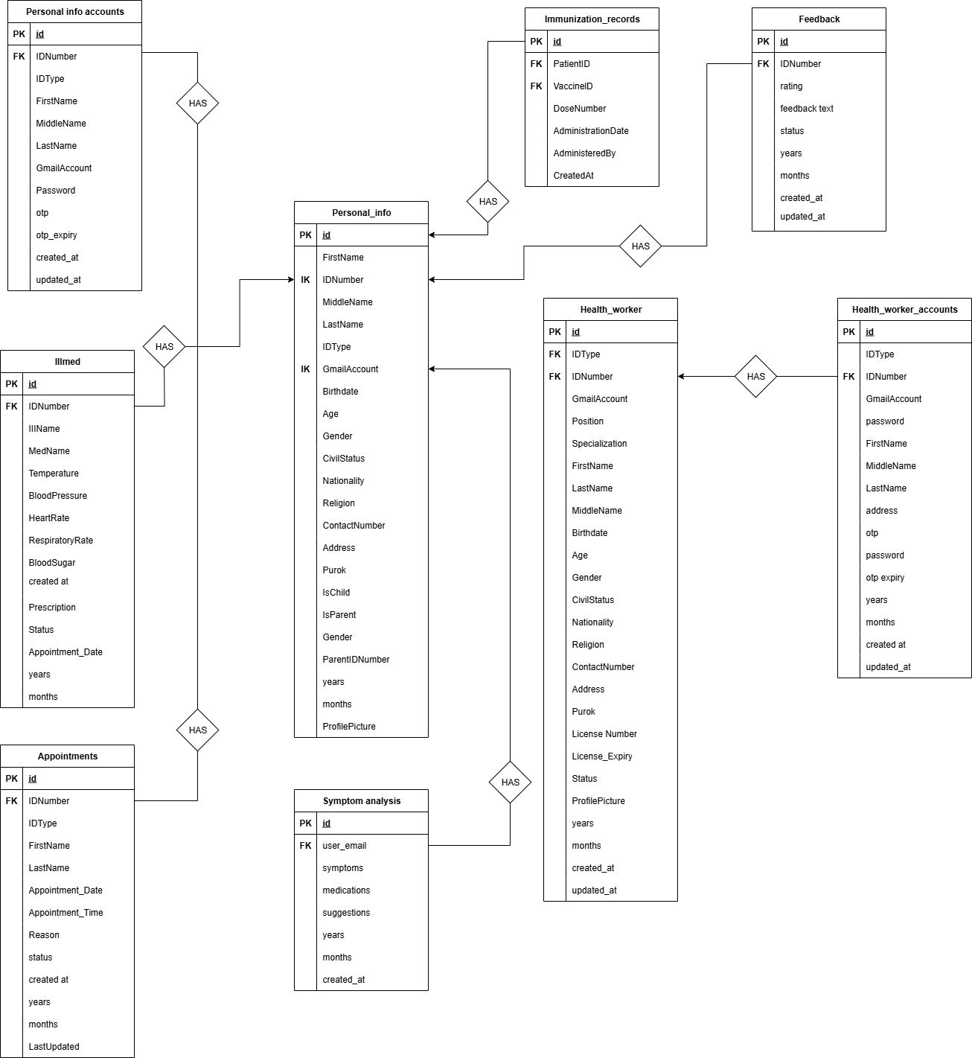

Figure 8. Entity-Relationship Diagram of the Study
Figure 8 showed the data structure and relationship between entities in the System. It demonstrated how data about personal accounts, personal information, medical records (illness, immunization, symptom analysis), health workers, and vaccine dispensing are organized and connected within the system. The ERD emphasized primary keys (PK) and foreign keys (FK) to establish relationships, ensuring data consistency and integrity throughout the system. The relationships included:
- One Personal_info_accounts HAS one Personal_info.
- One Personal_info HAS many Illmed entries.
- One Personal_info HAS many Immunization_records.
- One Personal_info HAS many Feedback entries.
- One Personal_info HAS many Symptom_analysis entries.
- One Personal_info HAS many Appointments.
- One Personal_info HAS many Health_worker entries.
- One Vaccines HAS many Immunization_records.
- One Vaccines HAS many Vaccine_dispensing entries.
- One Health_worker_accounts HAS one Health_worker.

Database Structure
Database name: center
Table 4. appointments
tbl_ appointments
Column | Type | Null | Default | Links to
id (Primary) | int(11) | No
IDNumber | varchar(50) | No
IDType | varchar(50) | No
FirstName | varchar(100) | No
LastName | varchar(100) | No
Appointment_Date | date | No
Appointment_Time | time | No
Reason | text | Yes | NULL
status | varchar(20) | Yes | Pending
created_at | timestamp | No | current_timestamp()

Table 5. feedback
tbl_ feedback
Column | Type | Null | Default | Links to
id (Primary) | int(11) | No
IDNumber | varchar(50) | No
rating | int(11) | No
feedback_text | text | No
status | enum('submitted', 'reviewed', 'addressed') | Yes | submitted
years | year(4) | Yes | year(curdate())
months | varchar(15) | Yes | NULL
created_at | timestamp | No | current_timestamp()
updated_at | timestamp | No | current_timestamp()

Table 6. health_worker
tbl_health_worker
Column | Type | Null | Default | Links to
id (Primary) | int(11) | No
IDType | varchar(50) | No
IDNumber | varchar(50) | No
GmailAccount | varchar(255) | No
Position | varchar(100) | No | NULL
Specialization | varchar(100) | Yes | NULL
FirstName | varchar(100) | No
LastName | varchar(100) | No
MiddleName | varchar(100) | Yes | NULL
Birthdate | date | No
Age | int(11) | Yes | NULL
Gender | varchar(20) | No
CivilStatus | varchar(50) | No
Nationality | varchar(100) | No
Religion | varchar(100) | Yes | NULL
ContactNumber | varchar(20) | No
Address | varchar(255) | No
Purok | varchar(50) | No
License_Number | varchar(50) | Yes | NULL
License_Expiry | date | Yes | NULL
Status | enum('Active', 'Inactive', 'On Leave') | No | Active
ProfilePicture | varchar(255) | Yes | NULL
years | year(4) | Yes | year(curdate())
months | varchar(15) | Yes | NULL
created_at | timestamp | No | current_timestamp()
updated_at | timestamp | No | current_timestamp()

Table 7. health_worker_accounts
tbl_ health_worker_accounts
Column | Type | Null | Default | Links to
id (Primary) | int(11) | No
IDType | varchar(50) | No
IDNumber | varchar(50) | No
GmailAccount | varchar(255) | No
password | varchar(255) | No
FirstName | varchar(100) | No
MiddleName | varchar(100) | Yes | NULL
LastName | varchar(100) | No
otp | varchar(6) | Yes | NULL
otp_expiry | datetime | Yes | NULL
years | year(4) | Yes | year(curdate())
months | varchar(15) | Yes | NULL
created_at | timestamp | No | current_timestamp()
updated_at | timestamp | No | current_timestamp()

Table 8. illmed
tbl_ illmed
Column | Type | Null | Default | Links to
id (Primary) | int(11) | No
IllName | varchar(255) | No
MedName | varchar(255) | Yes | NULL
Temperature | decimal(4,1) | Yes | NULL
BloodPressure | varchar(20) | Yes | NULL
HeartRate | int(11) | Yes | NULL
RespiratoryRate | int(11) | Yes | NULL
BloodSugar | varchar(20) | Yes | NULL
Prescription | text | Yes | NULL
IDNumber | varchar(50) | No
Status | varchar(20) | Yes | Critical
Appointment_Date | datetime | Yes | NULL
years | year(4) | Yes | year(curdate())
months | varchar(15) | Yes | NULL

Table 9. immunization_records
tbl_ immunization_records
Column | Type | Null | Default | Links to
id (Primary) | int(11) | No
PatientID | int(11) | No
VaccineID | int(11) | No
DoseNumber | int(11) | No | 1
AdministrationDate | date | No
AdministeredBy | varchar(100) | No
Notes | text | Yes | NULL
CreatedAt | timestamp | No | current_timestamp()

Table 10. intv
tbl_ intv
Column | Type | Null | Default | Links to
id (Primary) | int(11) | No
IDNumber | varchar(50) | No
what_you_do | text | Yes | NULL
what_is_your_existing_desease | text | Yes | NULL
have_you_a_family_history_desease | text | Yes | NULL
have_you_a_allergy | text | Yes | NULL
years | year(4) | Yes | year(curdate())
months | varchar(15) | Yes | NULL

Table 11. medical_history

Tbl_ medical_history
Column | Type | Null | Default | Links to
id (Primary) | int(11) | No
patient_id | int(11) | No |  | personal_info -> id
BloodType | varchar(5) | Yes | NULL
Allergies | text | Yes | NULL
ChronicIllnesses | text | Yes | NULL
PastSurgeries | text | Yes | NULL
CurrentMedications | text | Yes | NULL
FamilyHistory | text | Yes | NULL
FullyVaccinated | tinyint(1) | Yes | 0
AdditionalNotes | text | Yes | NULL
CreatedAt | timestamp | No | current_timestamp()
UpdatedAt | timestamp | No | current_timestamp()

Table 12. nurse_schedule
tbl_ nurse_schedule
Column | Type | Null | Default | Links to
id (Primary) | int(11) | No
unavailable_date | date | No
unavailable_start_time | time | No
unavailable_end_time | time | No
reason | text | Yes | NULL
years | year(4) | Yes | year(curdate())
months | varchar(15) | Yes | NULL
created_at | timestamp | No | current_timestamp()

Table 13. personal_info
tbl_ personal_info
Column | Type | Null | Default | Links to
id (Primary) | int(11) | No
FirstName | varchar(100) | No
LastName | varchar(100) | No
MiddleName | varchar(100) | Yes | NULL
IDType | varchar(50) | No
IDNumber | varchar(50) | No
GmailAccount | varchar(255) | No
Birthdate | date | No
Age | int(11) | No
Gender | varchar(20) | No
CivilStatus | varchar(50) | No
Nationality | varchar(100) | No
Religion | varchar(100) | Yes | NULL
ContactNumber | varchar(20) | No
Address | varchar(255) | No
Purok | varchar(50) | No
IsChild | tinyint(1) | Yes | 0
IsParent | tinyint(1) | Yes | 0
ParentIDNumber | varchar(50) | Yes | NULL
years | year(4) | Yes | year(curdate())
months | varchar(15) | Yes | NULL
ProfilePicture | varchar(255) | Yes | NULL

Table 14. personal_info_accounts
tbl_ personal_info_accounts
Column | Type | Null | Default | Links to
id (Primary) | int(11) | No
IDType | varchar(50) | No
IDNumber | varchar(50) | No
FirstName | varchar(100) | No
MiddleName | varchar(100) | Yes | NULL
LastName | varchar(100) | No
GmailAccount | varchar(255) | No
Password | varchar(255) | No
otp | varchar(6) | Yes | NULL
otp_expiry | datetime | Yes | NULL
created_at | timestamp | No | current_timestamp()
updated_at | timestamp | No | current_timestamp()

Table 15. recipient_vaccines
tbl_ recipient_vaccines
Column | Type | Null | Default | Links to
id (Primary) | int(11) | No
DispensingID | int(11) | No
PatientID | int(11) | No

Table 16. symptom_analysis
tbl_ symptom_analysis
Column | Type | Null | Default | Links to
d (Primary) | int(11) | No
user_email | varchar(255) | No
symptoms | text | No
medications | text | Yes | NULL
suggestions | text | Yes | NULL
years | year(4) | Yes | year(curdate())
months | varchar(15) | Yes | NULL
created_at | timestamp | No | current_timestamp()

Table 17. vaccines
tbl_ vaccines
Column | Type | Null | Default | Links to
id (Primary) | int(11) | No
VaccineName | varchar(100) | No
VaccineType | varchar(50) | No
TargetAgeGroup | varchar(50) | No
DoseCount | int(11) | No | 1
StockQuantity | int(11) | No | 0
ExpiryDate | date | No
Manufacturer | varchar(100) | No
Notes | text | Yes | NULL
CreatedAt | timestamp | No | current_timestamp()
UpdatedAt | timestamp | No | current_timestamp()

Table 18. vaccine_dispensing
tbl_ vaccine_dispensing
Column | Type | Null | Default | Links to
id (Primary) | int(11) | No
VaccineID | int(11) | No
Quantity | int(11) | No | 1
RecipientName | varchar(100) | Yes | NULL
Reason | varchar(100) | No
DispensedBy | varchar(100) | No
Notes | text | Yes | NULL
DispensedDate | timestamp | No | current_timestamp()

Evaluation Methodology
Evaluation of any system was a crucial part of its development. This determined if the system worked properly, met the objectives, and satisfied the users.

Research Design
This study adopts a Design and Development Research (DDR) approach, integrating descriptive, developmental, and evaluative research methods. The goal is to design, develop, and assess a Smart Mobile Application for Brgy. Health Center of Brgy. Poblacion, Pres. Quirino, S.K by addressing manual limitations in patient management, medicine tracking, and communication.
The study is structured into three major phases: (1) Planning and Requirement Gathering, (2) System Design and Development, and (3) System Evaluation. Each phase is guided by both qualitative and quantitative data collection and analysis to ensure the system meets the needs of its user’s barangay health workers, patients, and administrators.

Participants of the Study
The participants of this study are selected from key stakeholders directly involved in the use, management, and evaluation of the Heath Connect system. These include barangay health workers, health center administrators, patients or their guardians, IT support personnel, and the researchers themselves. The barangay health workers comprising midwives, nurses, and frontline health staff serve as the primary users of the system. They are responsible for managing patient records, scheduling appointments, tracking immunizations, dispensing medicines, and using the communication features. Their involvement is crucial to assess the system’s usability, functionality, and integration into daily health center operations.
The health center administrators are also significant participants, tasked with overseeing system-generated reports, approving medicine logs, and using dashboards to monitor health service activities. Their feedback ensures that the system supports effective management and decision-making. Patients and guardians, on the other hand, participate in the study by interacting with the system through features like online appointment scheduling, email notifications, appointment slips, and feedback submission. Their experiences provide insights into the system’s accessibility, convenience, and impact on healthcare engagement.
IT support personnel or local technical staff are included to assist with installation, deployment, and minor troubleshooting. Their role is essential in identifying technical issues and ensuring system sustainability. Lastly, the researchers themselves are participants in a dual capacity as system developers and evaluators responsible for collecting data, analyzing results, and refining the system based on user feedback. Overall, these participants are chosen based on their relevance to the system’s core functionalities, and their diverse perspectives contribute significantly to the development, implementation, and assessment of Health Connect.

Data Gathering Procedures and Statistical Tools
In this study, data gathering was conducted through a combination of quantitative and qualitative methods to ensure a well-rounded evaluation of the Health Connect system. Initially, the researchers performed informal observations and structured interviews with barangay health workers and health administrators to gather baseline information about their current processes, challenges, and expectations regarding digital health systems. These insights helped define the system’s core requirements and design. Once a functional prototype was developed, surveys were distributed to users, including health workers and patients, to assess usability, efficiency, and satisfaction with the system. The System Usability Scale (SUS) was used to measure user-friendliness, while custom Likert-scale questionnaires evaluated aspects such as performance, accessibility, and ease of use.
During the post-deployment, feedback sessions and follow-up interviews were conducted to gather in-depth user impressions, particularly on system effectiveness and real-life applicability in a barangay setting.
For the statistical treatment of data, descriptive statistics such as frequency, percentage, mean, and standard deviation were employed to analyze survey results and usage data. These tools allowed the researchers to interpret user behavior, performance trends, and satisfaction levels in a simplified yet meaningful way. The findings were then triangulated with qualitative feedback to identify areas of strength and aspects needing improvement, ensuring that the final recommendations were based on a balanced understanding of both system performance and user experience.
Table 9. Rating Scale used in the Study
CODE | MEAN RANGE | DESCRIPTION | LEGEND
5 | 4.20-5.00 | Strongly Agree | SA
4 | 3.40-4.19 | Agree | A
3 | 2.60-3.39 | Moderately Agree | MA
2 | 1.80-2.59 | Disagree | D

Formula For Weighted Mean:
$$x=\frac{Σx_{i}}{n}$$
Where:
$x$ = mean score
n = number of respondents
$∑x_{i}$ = frequency
Formula for Standard Deviation:
$s=\sqrt{\frac{∑{\left(x-\overline{x}\right)}^{2}}{n-:}}$

